# IICT6203 - Database Programming II

## Worksheet 02 - Functions

1. Create a function that will return 1 if the value passed as a parameter is greater than 0 and less than or equal to 500.00, otherwise 0 is returned. The data type of the parameter should be the same as that of payment amount in payments. Name the function udf_isValidAmount.
2. Test the new function with the following values: -50, 0, 50, 500. Compare your output with the following output:



1. Create a function that accepts the username as a parameter and then it must return 1 if the account is active, otherwise 0. Name the function udf_isUserActive..
2. Test the function for each username. Compare your output with the following output:

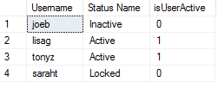

1. Create a function that will display the order total. The total for each can be worked out by finding the total of each product quantity multiplied by the product price. Name the function udf_getOrderTotal.
2. Test the previous statement with all orders. Compare your output with the following output:

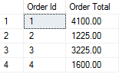

1. Create a function that returns the total amount of valid payments for a given order. The payments are valid if the is_valid attribute is 1. Name the function udf_getValidPayments and the return data type is NUMERIC(6,2).
2. Test the previous function against all orders. Compare your output with the following output:

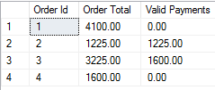

1. Create a function that lists the order ID, order date, account ID, status ID and status name for all orders that have not been paid in full (Payment Pending), for a specific account id. Name the function udf_pendingOrders.
2. Test the previous function by listing all usernames and their orders if any were placed. Compare your output with the following output:



